

Health Care Application  
Form 10-10EZ

Version 2  
Last Modified: July 9, 2024

Table of Contents

Health Care Application Overview and Navigation 3

Health Care Application Introduction Page 6

Signed out users 6

Signed in users: LOA1 (not identity verified) 10

Signed in users: LOA3 (identity verified) 11

Filling Out the Health Care Application 15

Veteran Information 17

Veteran information page 1: Names 17

Veteran information page 2: Social Security number 22

Veteran information page 3: Date of birth 23

Users must select the month and day  23

Veteran information page 4: Place of birth 23

Veteran information page 5: Mother’s surname at birth 24

Veteran information page 6: Birth sex 24

Veteran information page 7: Race, ethnicity, or origin 25

Veteran information page 8: Mailing address 26

Veteran information page 9: Email and phone number 29

VA Benefits 31

VA benefits page 1: Current compensation from VA 31

VA benefits page 2: Current compensation (Medicaid ineligible) 35

Military Service 36

Military service page 1: Branch and dates of service 36

Military service page 2: Service history

[Military service page 3:](https://docs.google.com/document/d/1q11ictK4zNJR4xZSBCcdndDI_PTItqzqFKfw8N3c1cA/edit?pli=1#bookmark=id.19c6y18) Toxic Exposure

[Military service page 4: Cleanup or response efforts](https://docs.google.com/document/d/1q11ictK4zNJR4xZSBCcdndDI_PTItqzqFKfw8N3c1cA/edit?pli=1#bookmark=id.19c6y18)

[Military service page 5: Service in Gulf War locations](https://docs.google.com/document/d/1q11ictK4zNJR4xZSBCcdndDI_PTItqzqFKfw8N3c1cA/edit?pli=1#bookmark=id.19c6y18)

[Military service page 6:](https://docs.google.com/document/d/1q11ictK4zNJR4xZSBCcdndDI_PTItqzqFKfw8N3c1cA/edit?pli=1#bookmark=id.19c6y18) Service dates for Gulf War locations

[Military service page 7:](https://docs.google.com/document/d/1q11ictK4zNJR4xZSBCcdndDI_PTItqzqFKfw8N3c1cA/edit?pli=1#bookmark=id.19c6y18) Operations

[Military service page 8:](https://docs.google.com/document/d/1q11ictK4zNJR4xZSBCcdndDI_PTItqzqFKfw8N3c1cA/edit?pli=1#bookmark=id.19c6y18) Agent Orange locations

[Military service page 9:](https://docs.google.com/document/d/1q11ictK4zNJR4xZSBCcdndDI_PTItqzqFKfw8N3c1cA/edit?pli=1#bookmark=id.19c6y18) Other toxic exposures

[Military service page 10: Other toxic](https://docs.google.com/document/d/1q11ictK4zNJR4xZSBCcdndDI_PTItqzqFKfw8N3c1cA/edit?pli=1#bookmark=id.19c6y18) exposure

[Military service page 11:](https://docs.google.com/document/d/1q11ictK4zNJR4xZSBCcdndDI_PTItqzqFKfw8N3c1cA/edit?pli=1#bookmark=id.19c6y18) Dates of exposure

Military service page 12: Upload discharge papers 39

Household Information 41

Household information page 1: Financial disclosure 41

Household information page 2: Marital status 43

Household information page 3: Spouse’s information 45

Household information page 4: Dependents’ information 46

Household information page 5: Annual income 47

Household information page 6: Previous calendar year’s deductible expenses 49

Household information page 7: Spouse’s financial support 49

Household information page 8: Dependent’s information 50

Household information page 9: Dependent’s personal information 53

Household information page 11: Dependent’s additional information 55

Household information page 12: Dependent’s annual income (previous year) 57

[Household information page 10: Dependent’s education expenses](https://docs.google.com/document/d/1q11ictK4zNJR4xZSBCcdndDI_PTItqzqFKfw8N3c1cA/edit?pli=1#bookmark=id.25b2l0r) 55

Household information page 13: Review your dependents 59

Household information page 14: Annual income 61

Household information page 15: Previous calendar year deductible expenses 63

Insurance Information 65

Insurance information page 1: Medicaid 65

Insurance information page 2: Medicare 66

Insurance information page 3: Medicare detail 67

Insurance information page 4: Other coverage 69

Insurance information page 5: VA facility 72

Review Application 74

Health Care Application Issues 82

Questions about the content of the application 82

Application is pre-filled with incorrect information 82

Veteran can’t move forward in their application 82

Veteran can’t upload a document 83

Veteran is having trouble upgrading their LOA1 account to an LOA3 account 83

# 

# Health Care Application Overview and Navigation

Users of VA.gov can apply for health care benefits by filling out the online application (VA form 10-10EZ). Users with no account, an LOA1 account (not identity verified), or an LOA3 account (identity verified) can access and complete the health care application.

A user can find the health care application at https://www.va.gov/health-care/apply-for-health-care-form-10-10ez/introduction or at the following locations on VA.gov:

* In the main menu drop-down

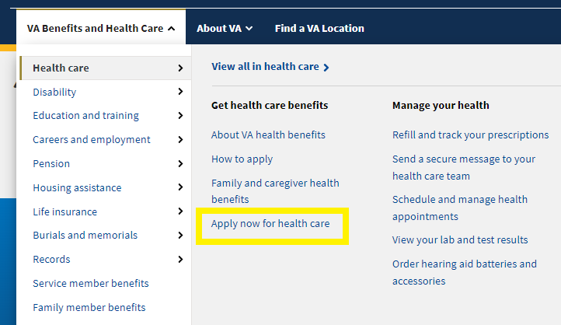

* In the health care benefit hub: <https://www.va.gov/health-care/>

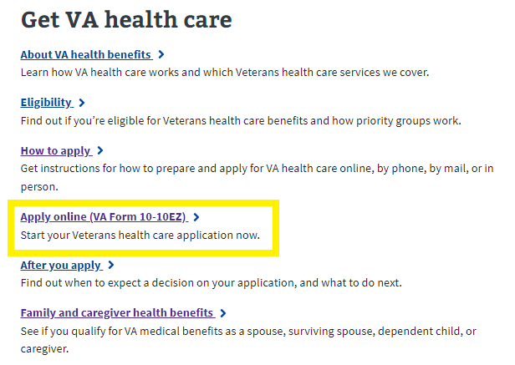

# Health Care Application Introduction Page

Currently, the Health Care Application is available on VA.gov (https://www.va.gov/health-care/apply-for-health-care-form-10-10ez/introduction ) to all users who come to the site, whether they are signed in or signed out, or whether they are LOA1 or LOA3.

## Signed out users

Signed out application introduction page: https://www.va.gov/health-care/apply-for-health-care-form-10-10ez/introduction .

Signed out users will access the health care application through the health care application introduction page.

On this page, we strongly encourage people to log in before applying, and have a call out to previous applicants to log in and check their status. These are at the top of the health care application introduction page:

Signed out ID page link: [https://www.va.gov/health-care/apply-for-health-care-form-10-10ez/id-form](https://staging.va.gov/health-care/apply-for-health-care-form-10-10ez/id-form)

Signed out users can access the health care application. However, to do so, they will be filtered through a screener ID page where their entered personal information is used to scan the MVI (Master Veteran Index) and the ESR (Enrollment System) for existing records. They are shown the screener ID page immediately upon clicking “Start your application without signing in.”

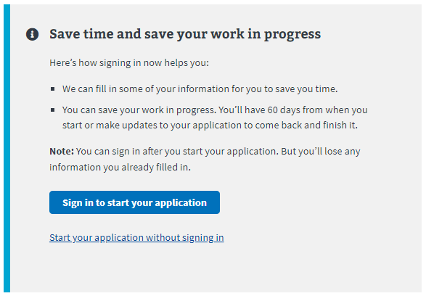

The screener ID page asks them for their first and last name, date of birth (DOB), and Social Security number (Social Security number).

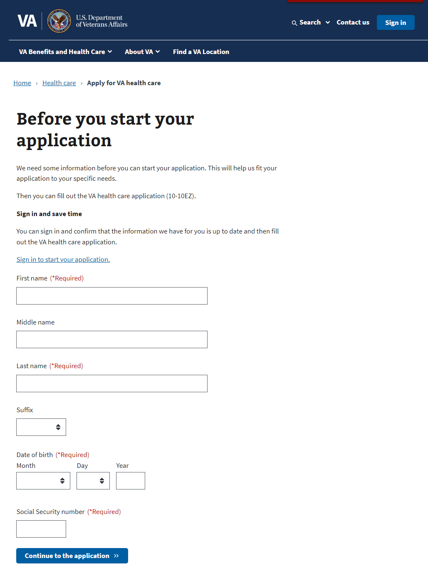

Upon filling out the ID page screener and pushing the “Continue to the application” button, MVI and ESR are queried. Potential outcomes include:

* **User is not found in MVI or the ESR**: These users will be passed through to the health care application. As part of this application, there will be a section where they can upload their DD214 or other discharge documents to help verify their service.
* **User is found in MVI but not in ESR**: These users will be passed through to the health care application but will not be asked to include a DD214 or other discharge documents.
* **User is found in MVI and in ESR**: These users will not be able to access the health care application from a signed-out state because finding them in the ESR means that they have applied for health care previously. They need to sign in to VA.gov to see their health care status before accessing the application.

Users found in MVI and ESR will see the following alert that directs them to sign in to continue. They won’t be able to complete the application until they do:

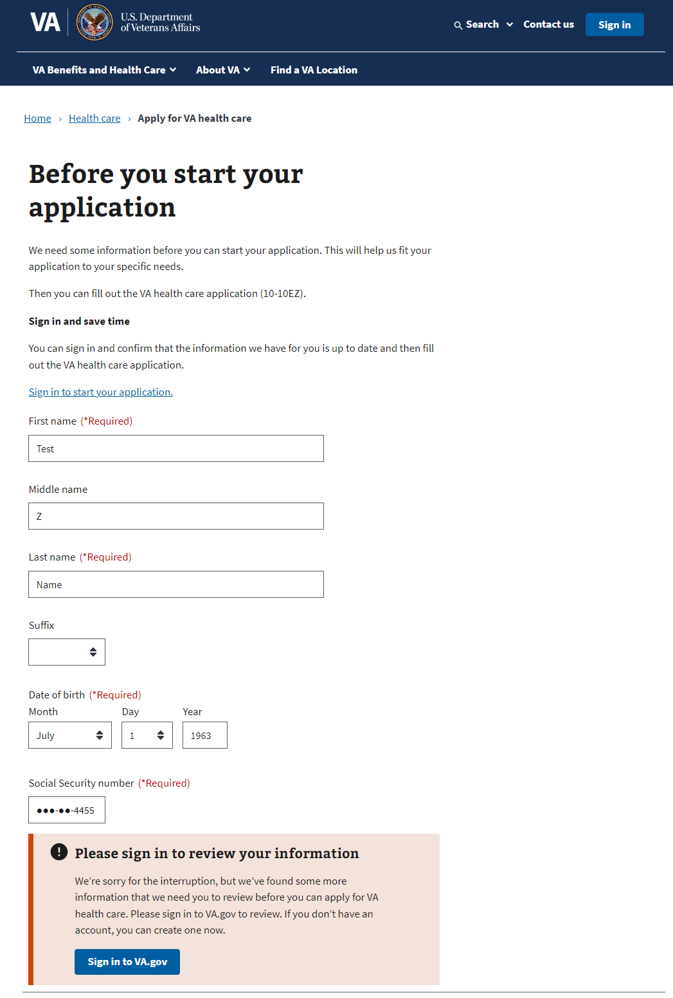

## Signed in users: LOA1 (not identity verified)

Signed in LOA1 users will see the following alert when they go to the health care application introduction page at https://www.va.gov/health-care/apply-for-health-care-form-10-10ez/introduction . LOA1 users won’t be able to access the health care application without first verifying their identity and becoming LOA3. This is to make sure that all users who apply are scanned through the ESR to verify whether they have or have not applied for health care previously.

## 

## Signed in users: LOA3 (identity verified)

For signed in LOA3 users, we will automatically perform a scan on the backend for existing health care records in the enrollment system (ESR) when they go to the application introduction page at https://www.va.gov/health-care/apply-for-health-care-form-10-10ez/introduction .

For users who are not found in the enrollment system (ESR), they will be able to go straight into the health care application:

For users who are found in the ESR, they will see their current health care status. There are 25 potential statuses users could see:

* Veteran is enrolled in VA healthcare.
* Veteran has a pending application.
* Veteran did not qualify for VA health care this time around, but they may qualify in the future if circumstances change (e.g., their income was too high, or they did not have a service-connected disability at the time of application).
* Veteran did not qualify (is ineligible) for VA health care because of their service record or other circumstances.
  + There are many reasons why someone may be ineligible for health care; the most common being they did not serve for 24 consecutive months of active duty, their character of service was not high enough, or their service could not be verified.
  + We are trying to display as many as 12 reasons someone may have been found ineligible.
* Veteran is deceased.
* Veteran had VA health care but canceled it; or they were offered it but declined it.
* Veteran had an open/incomplete application for a year, so it was closed.
* A service member has applied too early and is still on active duty.

For all Veterans who have applied for health care before and see the health care status on the application introduction page, they should call the health enrollment center at 877-222-VETS ([877-222-8387](tel:+18772228387)) if they have questions.

Here are 2 visual examples of the alerts:

1. An alert that shows that this user is already enrolled in health care:

1. An alert that they have applied before and didn’t qualify at that time:

# Filling Out the Health Care Application

There are 6 sections in the health care application, but not everyone is shown the entire application:

1. Veteran information
2. VA benefits
3. Military service
4. Household information
5. Insurance information
6. Application review

Some users will be able to fill out a shortened version of the application, skipping some sections. Veterans will be shown the shortened form if they have a disability rating of equal to or greater than 50 percent.

Please note: For authenticated users, the system will prefill the information we already have on file. The user will have the ability to review and update some of this as they complete the application.

Each section has multiple pages of questions that the user must enter to complete the application. For authenticated users, the application is automatically saved as the user completes the application, and they have the option to “Finish this application later.”

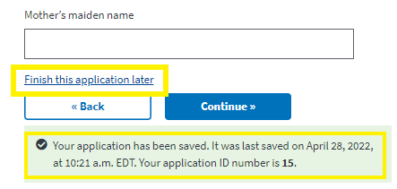

To move forward through the application, the user clicks “Continue.” They will not be able to move forward until all required information on the page is complete. An example error message is shown below. To go back to a section of the application, the user can use the back button.

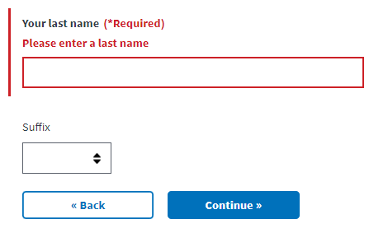

The application also has a status bar at the top of each page of the application to indicate how far along in the application a Veteran is. It progresses when a new section is complete, not based on the number of questions completed:

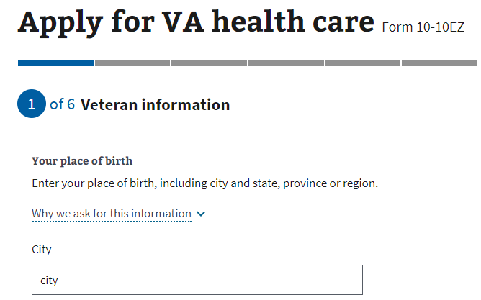

## 

## Veteran Information

### Veteran information page 1: Names

Authenticated users are shown their name, and DOB in a locked state. If they need to update this information, they will need to contact the VA Benefits Hotline at 800-827-1000.

Authenticated user

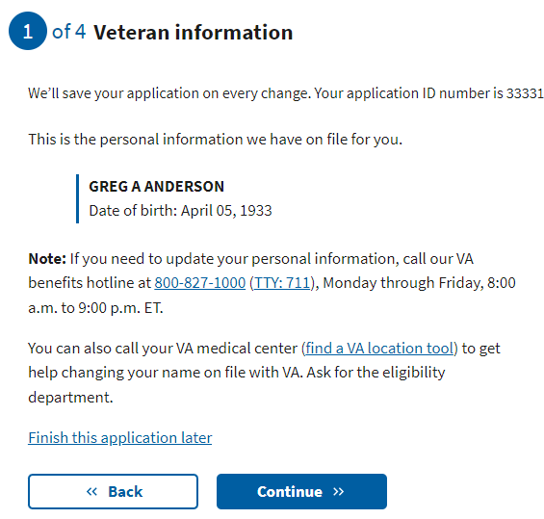

Authenticated users with information in their profile that qualifies them to have a shortened form will be alerted to that immediately after this page. If they do not see that page, they may still qualify later in the application. These users will need to input their place of birth and then move on to mother’s surname at birth.

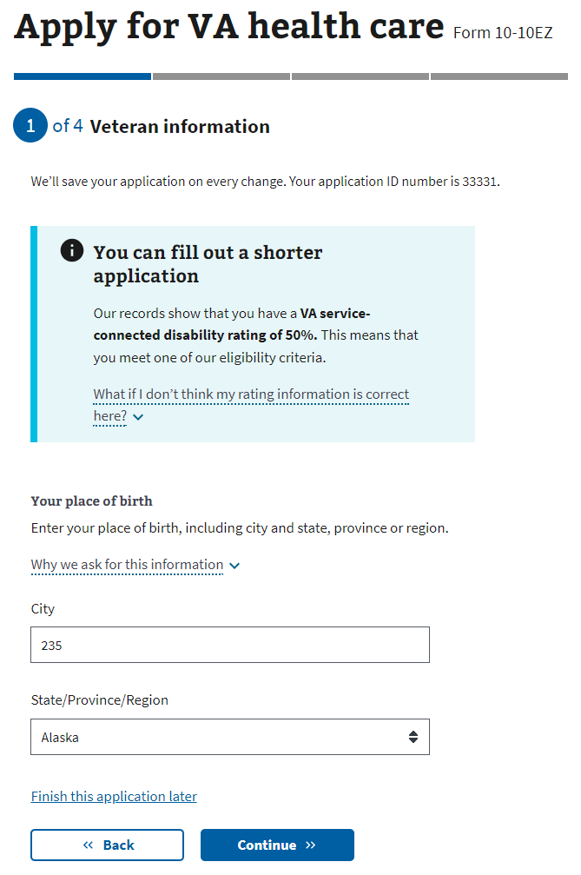

Unauthenticated user

**Once the user entered their name, DOB and SSN and they are not found in MVI or the ESR, the form will display their name, DOB and SSN that was previously entered.**

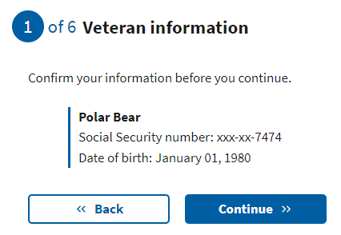

### 

### Veteran information page 4: Place of birth

The user must enter the city name and select the state from the drop-down. This currently doesn’t support international locations. Note: For those born outside the U.S., they can enter the city and leave the state blank.

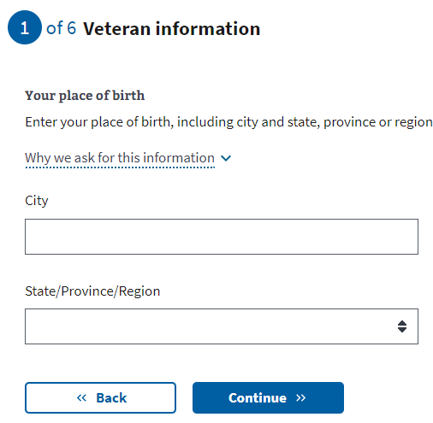

### 

### Veteran information page 5: Mother’s surname at birth

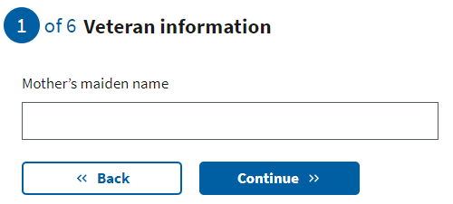

### Veteran information page 6: Birth sex

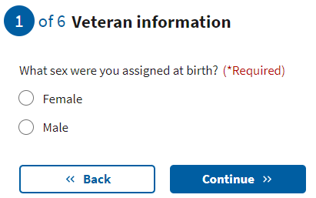

### 

### Veteran information page 7: Race, ethnicity or origin

The user may select one or more options. This is optional.

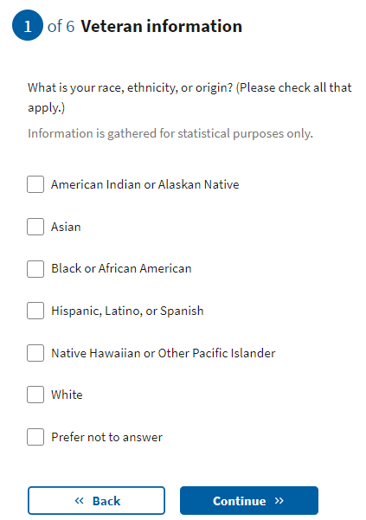

### 

### Veteran information page 8: Mailing address

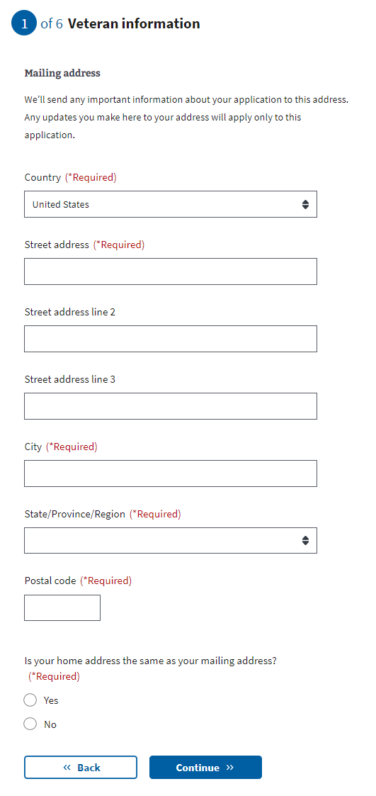

Note: If the user indicates that their mailing address is different from their home address, they will be asked to enter their home address on the following page.

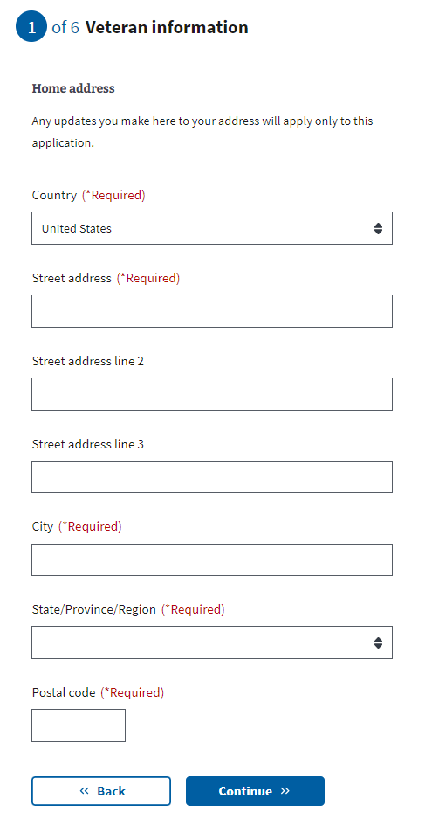

### 

### Veteran information page 9: Email and phone number

Users may choose to provide their email address and/or home/mobile telephone numbers. If the user decides to share this information, these contact methods will be used to communicate with the Veteran during the application process. If they do not provide either, all communication will be delivered to their mailing address via paper mail.

Users who are filling out the short form will be taken to the military service - toxic exposure section after this page.

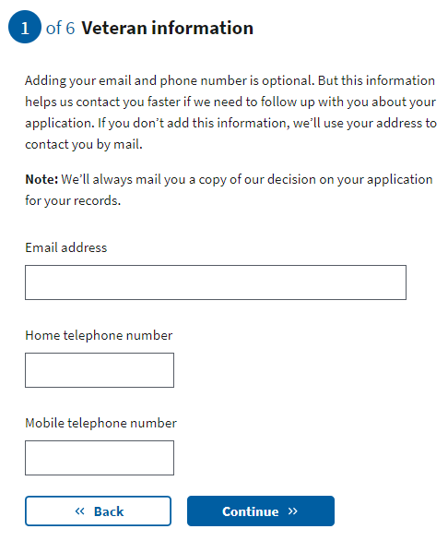

## VA Benefits

### VA benefits page 1: Current compensation from VA

This next section asks for the Veteran’s current compensation, based on their service-connected disability rating. The drop-down information shown here explains how we use the information. If they indicate that they receive compensation for a disability rating of up to 40 percent, they will move on to the next page to enter their military service information.

If the Veteran indicates that they do not receive any compensation, they will be asked about their VA pension.

If they indicate they receive compensation for a disability rating of 50 percent or higher, they will be redirected to a shortened version of the application. This shortened form skips the following sections:

1. Military service - Branch and service dates
2. Household information

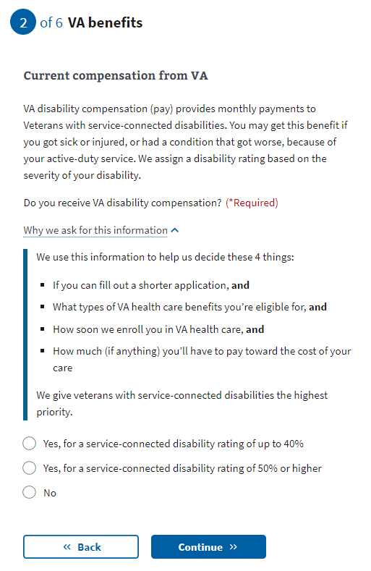

If the Veteran indicates that they have a disability rating of 50 percent or higher, they will be asked to confirm their selection. They will see this page, explaining why they need to confirm their selection.

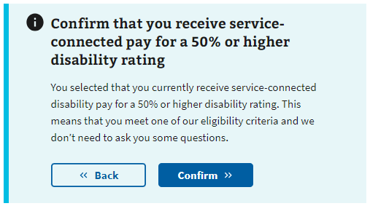

Once they have confirmed they are receiving service-connected pay for a 50 percent or higher disability rating, they will be informed they can fill out the shortened form of the application and an explanation as to why. Please proceed to the military service - toxic exposure section.

### VA benefits page 2: Current compensation (Medicaid ineligible)

This question is only shown if the user indicates “No” to the previous VA disability compensation question.

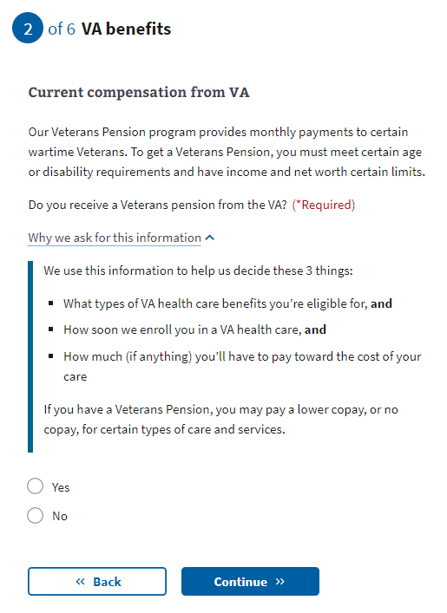

## 

## Military Service

### Military service page 1: Branch and dates of service

The application will check dates to ensure their validity. For example:

* Not 18 years old at input service start date
* Input service end date is before service start date

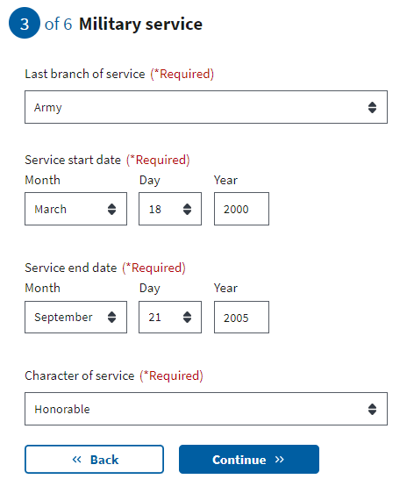

### 

### Military service page 2: Service history

The user may select one or more options. This is optional.

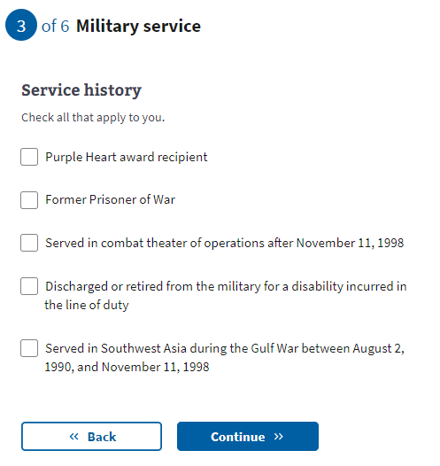

### Military service page 3: Toxic Exposure

This page is to explain about toxic exposure and provide resources a user might want to access to learn more. A user can choose whether or not to answer questions regarding military service history and any toxic exposure (or potential toxic exposure). The questions that follow will be asking about specific locations, operations, and toxins where the Veteran may have been exposed.

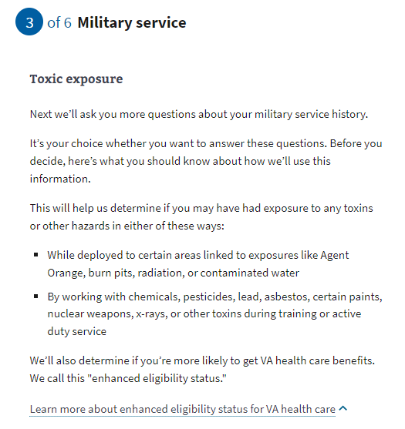

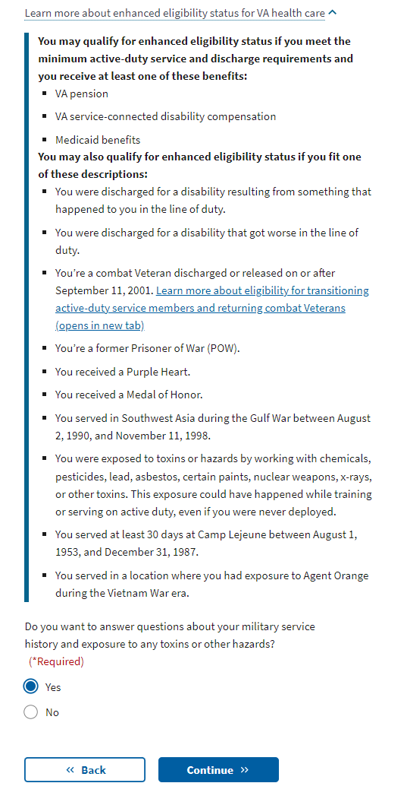

### Military service page 4: Cleanup or response efforts

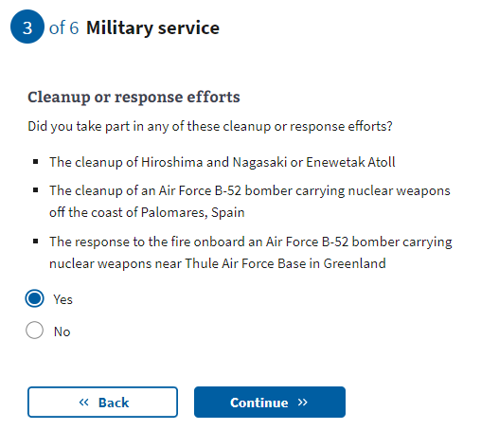

[Military service page 5: Service in Gulf War locations](https://docs.google.com/document/d/1q11ictK4zNJR4xZSBCcdndDI_PTItqzqFKfw8N3c1cA/edit?pli=1#bookmark=id.19c6y18)

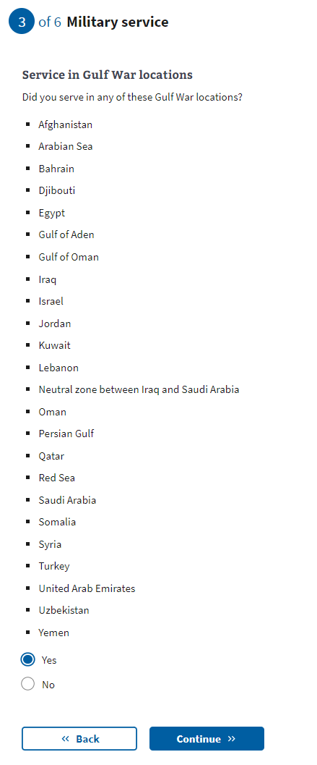

[Military service page 6:](https://docs.google.com/document/d/1q11ictK4zNJR4xZSBCcdndDI_PTItqzqFKfw8N3c1cA/edit?pli=1#bookmark=id.19c6y18) Service dates for Gulf War locations

These date fields are optional. A user can provide a month and year, or a date range if they know this information. If the user does not know or does not want to estimate a date or range, they can leave these optional fields blank and continue to the next page.

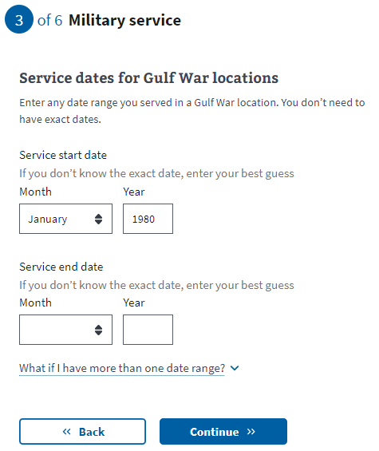

[Military service page 7:](https://docs.google.com/document/d/1q11ictK4zNJR4xZSBCcdndDI_PTItqzqFKfw8N3c1cA/edit?pli=1#bookmark=id.19c6y18) Operations

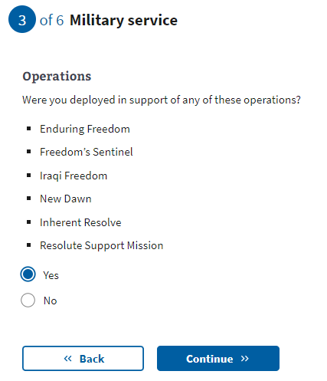

[Military service page 8:](https://docs.google.com/document/d/1q11ictK4zNJR4xZSBCcdndDI_PTItqzqFKfw8N3c1cA/edit?pli=1#bookmark=id.19c6y18) Agent Orange locations

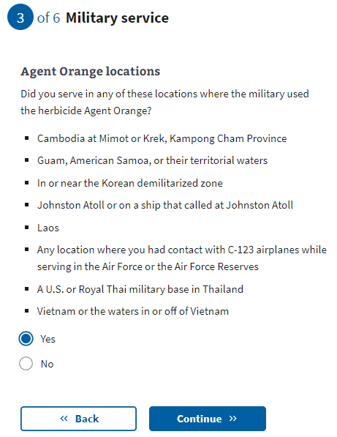

[Military service page 9:](https://docs.google.com/document/d/1q11ictK4zNJR4xZSBCcdndDI_PTItqzqFKfw8N3c1cA/edit?pli=1#bookmark=id.19c6y18) Other toxic exposures

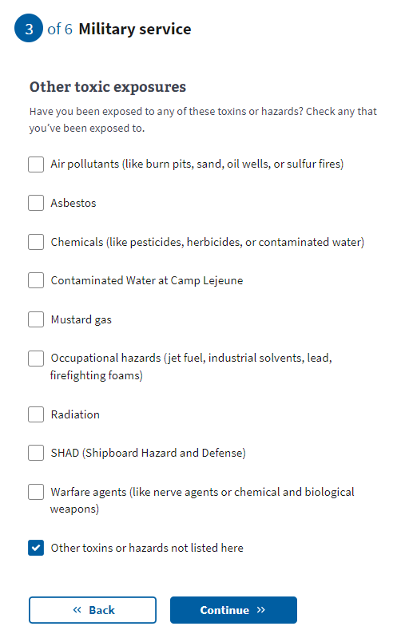

[Military service page 10: Other toxic](https://docs.google.com/document/d/1q11ictK4zNJR4xZSBCcdndDI_PTItqzqFKfw8N3c1cA/edit?pli=1#bookmark=id.19c6y18) exposure

If the user selects “Other toxins or hazards not listed here” from the previous question, they will be asked to list the toxin(s) that they may have experienced exposure.

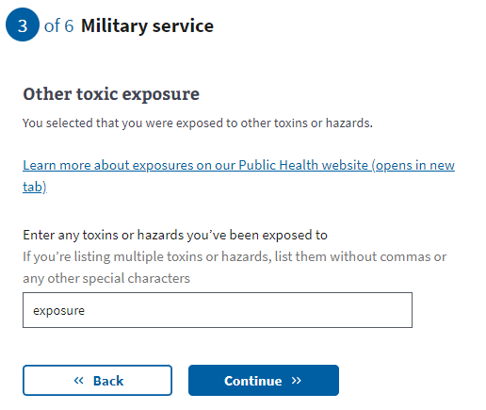

[Military service page 11: Dates of](https://docs.google.com/document/d/1q11ictK4zNJR4xZSBCcdndDI_PTItqzqFKfw8N3c1cA/edit?pli=1#bookmark=id.19c6y18) exposure

These date fields are optional. A user can provide a month and year, or a date range if they know this information. If the user does not know or does not want to estimate a date or range, they can leave these optional fields blank and continue to the next page.

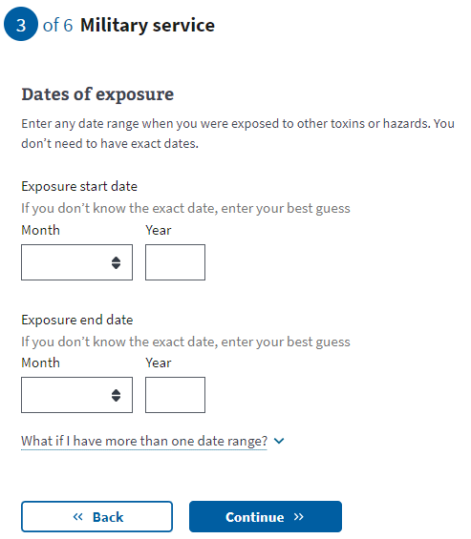

### Military service page 12: Upload discharge papers

A user who has been verified in MVI or ESR will not see this page. Users that have not been verified in these systems will need to upload their DD214 or other discharge documents to help verify their service. If the Veteran needs to request any of these documents, they can do so here: <https://www.va.gov/records/get-military-service-records/>.

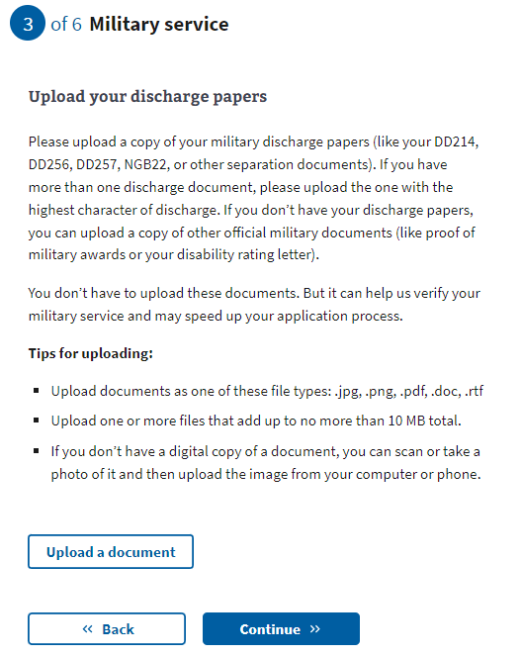

## Household Information

### 

### Household information page 1: Household financial information

This information page is to explain that financial information is being requested and how it will be used to determine eligibility. It also includes a list of eligibility factors that may also be used to determine eligibility.

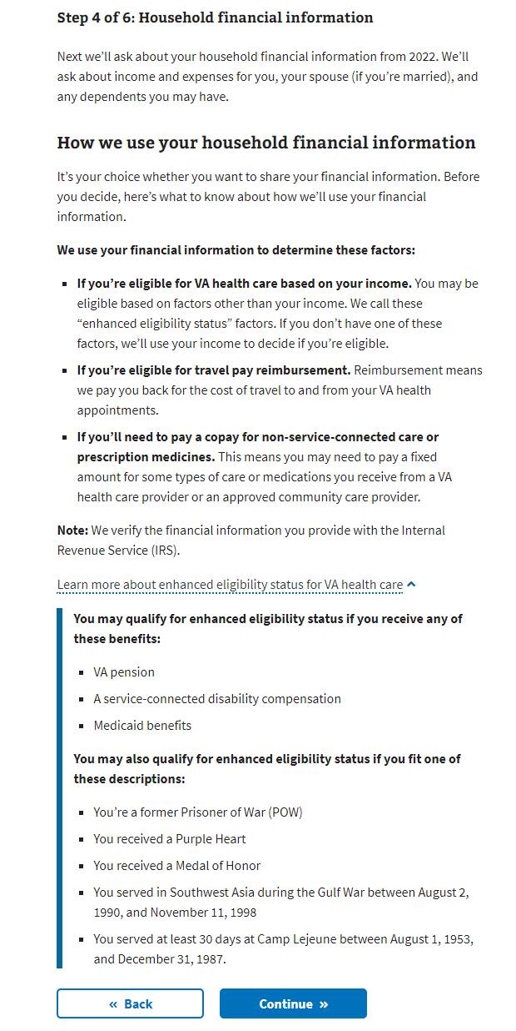

### Household information page 2: Sharing your household financial information

A user can choose whether or not to disclose financial information on this page; however, if the user selects they do not want to provide their financial information and clicks continue, they will be shown the below message:

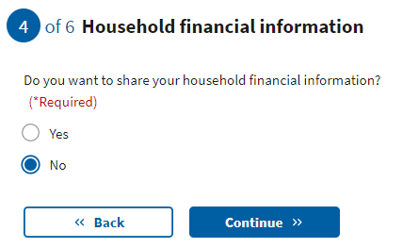

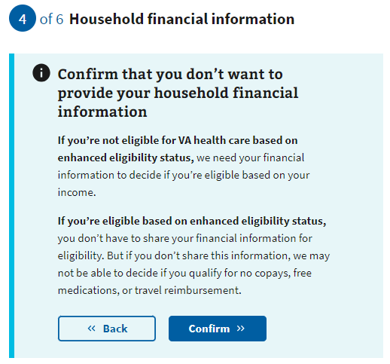

### Household information page 3: Information page

If the user selected Yes to provide their financial information, the user will see an information page explaining what income and deductibles they will need to provide.

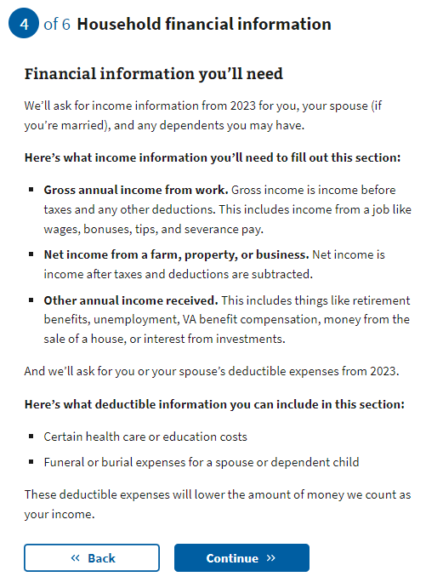

### Household information page 4: Marital status

The user will now need to indicate their marital status from the drop-down.

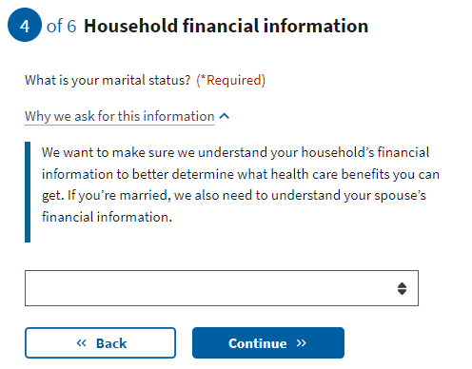

### Household information page 5: Spouse’s personal information

If the Veteran has chosen to share their financial information and indicates they are married or separated, they will be required to fill out their spouse’s information.

If they chose not to disclose their financial information, they will be taken to the insurance information section of the application once they’ve indicated their marital status.

### 

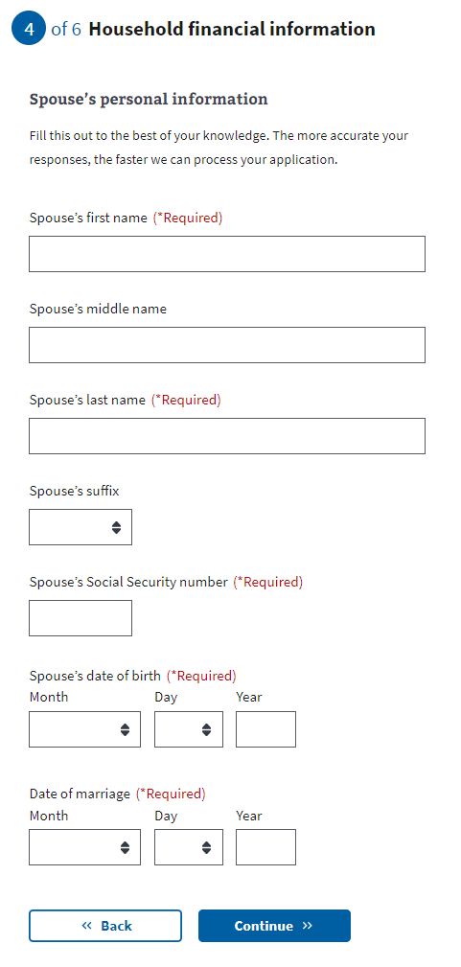

### 

### Household information page 6: Spouse’s additional information

The Veteran will be asked whether their spouse lived with them during the previous year, and whether they live with them now. This will help determine whether the spouse should be considered a dependent.

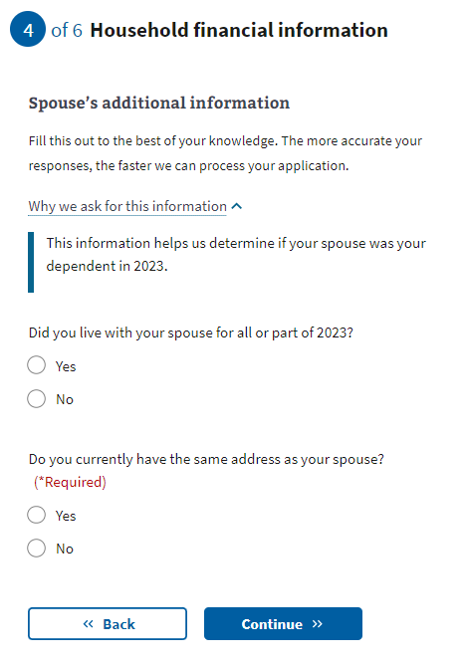

### Household information page 7: Spouse’s financial support

If the Veteran indicates that they did not live with their spouse any time in the previous year, they will be asked whether they provided financial support to their spouse during that time.

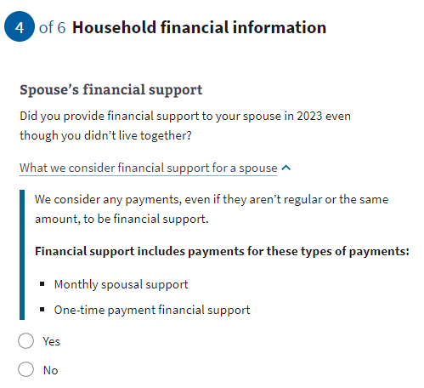

### Household information page 8: Dependent’s information

If the Veteran indicates that they have at least one dependent, the form will ask them to input information about the dependent. They will have the option to enter more than one dependent.

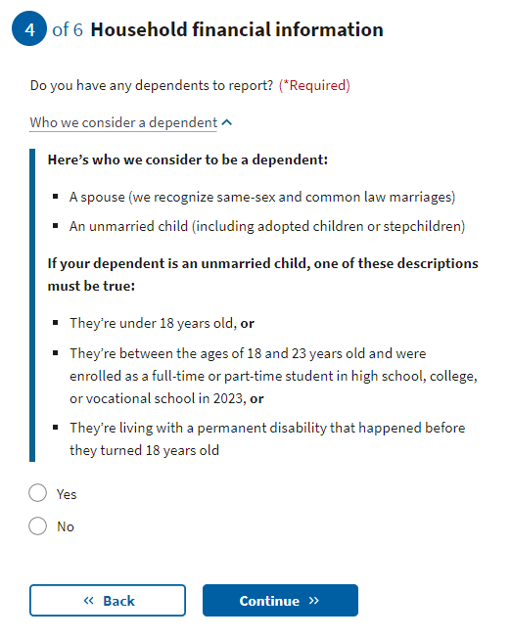

Examples of when someone becomes your dependent:

* **Birth of a child**: The DOB would be the date on which the child became your dependent.
* **Adoption**: The official date of adoption would be the date on which the child became your dependent.

### Household information page 9: Dependent’s personal information The Veteran will be asked to provide the dependent’s information.

### 

### 

### Household information page 10: Dependent’s additional information

The Veteran will be asked whether their dependent was permanently disabled before turning 18 years old, whether they lived with them during the previous year, and if the dependent earned any income in the previous year.

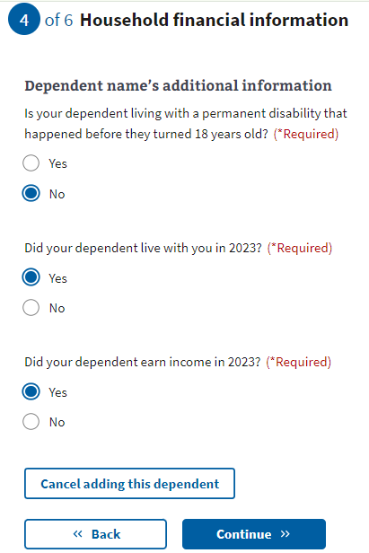

### Household information page 11: Dependent’s annual income (previous year)

If the Veteran indicates that their dependent earned income during the previous year, they will be asked for the income details.

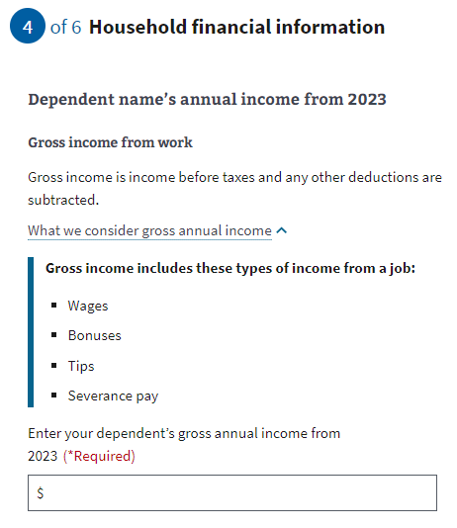

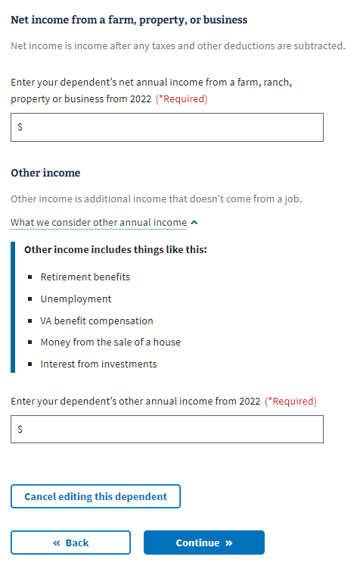

### 

### Household information page 12: Dependent’s education expenses

If the dependent is between the ages of 18 and 24 years old, the Veteran will be asked about education expenses.

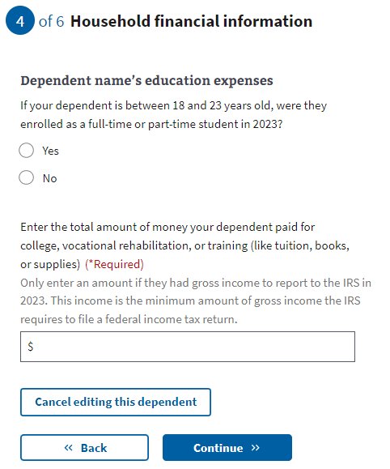

### Household information page 13: Review your dependents

The user can add additional dependents by answering “Yes” to the question “Do you have another dependent to report?”

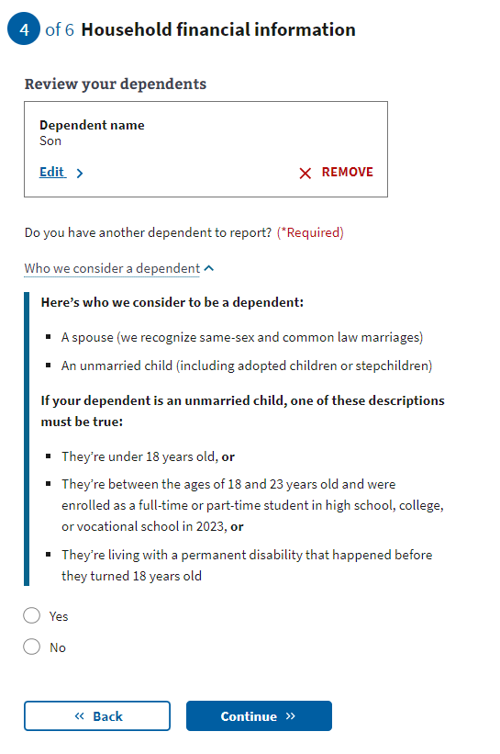

### Household information page 14: Annual income

The user will need to provide the requested financial information in the following forms. The application will ask about their annual income and their previous year’s deductible expenses. If the Veteran indicated they were married, they will also be asked for their spouse’s annual income.

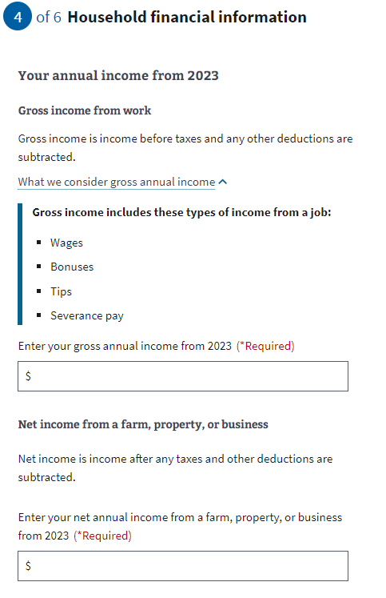

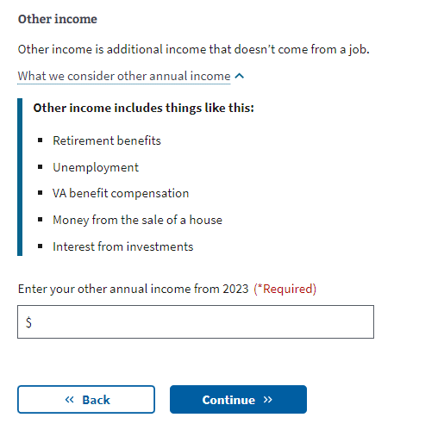

### Household information page 15: Previous calendar year’s deductible expenses

### 

### 

## 

## 

## 

## Insurance Information

### Insurance information page 1: Medicaid

All users are shown this page. The user needs to indicate whether they’re eligible for Medicaid. Those filling out the shortened application will see an alert on this and all remaining pages of their application that indicates that they are filling out a shortened application and why.

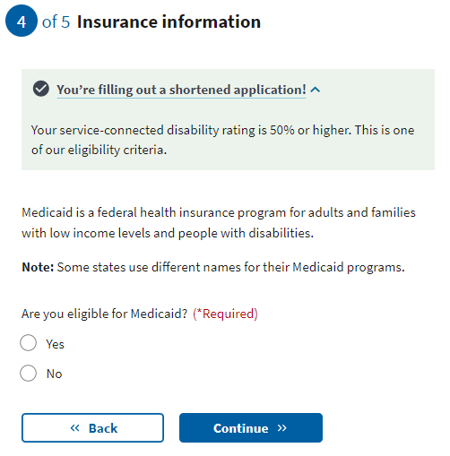

### Insurance information page 2: Medicare

If the user is not eligible for the shortened form, they will be asked about Medicare Part A. The user needs to indicate whether they’re enrolled in Medicare Part A. If they select “Yes,” the next page will request the effective date of their Medicare Part A coverage.

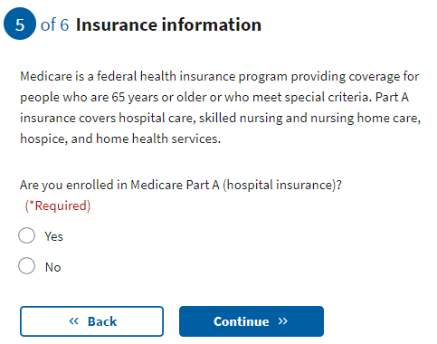

### 

### Insurance information page 3: Medicare detail

The user will need to input the effective date of their Medicare Part A, and their Medicare claim number.

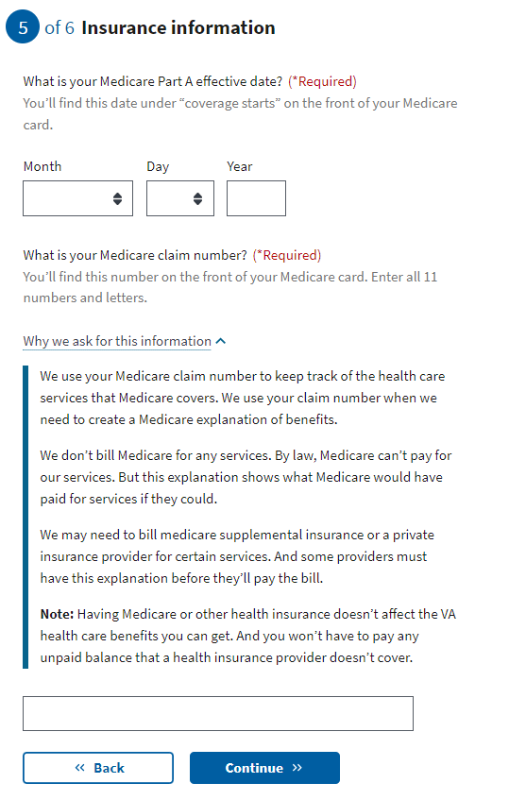

### Insurance information page 4: Other coverage

The user needs to indicate whether they have any additional health insurance coverage. If they do, the form will expand to allow them to input that information.

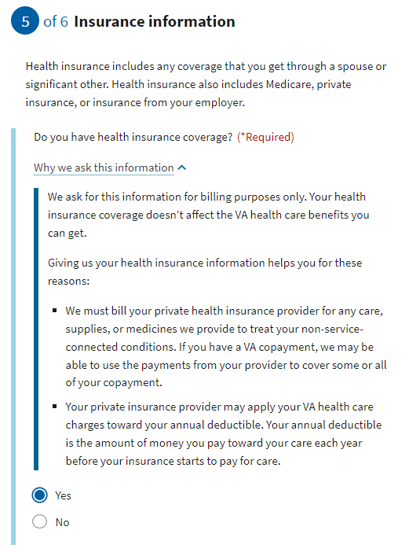

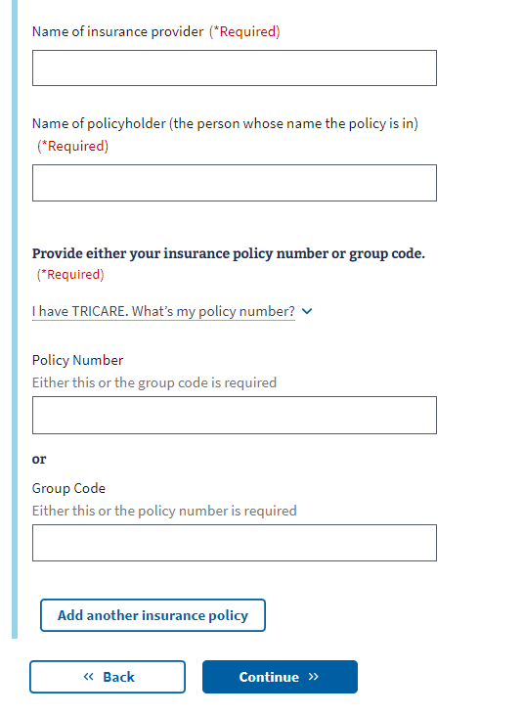

### Insurance information page 5: VA facility

The user will need to indicate whether they’re applying to get minimum essential coverage under the Affordable Care Act. Then they will select their preferred VA medical facility by selecting the state and facility from the second drop-down menu. If they need assistance locating a facility, they can use the [VA Facility Locator](https://www.va.gov/find-locations) by clicking on the link below the “Center or clinic” drop-down.

The Veteran can indicate whether they want VA to contact them to schedule their first appointment.

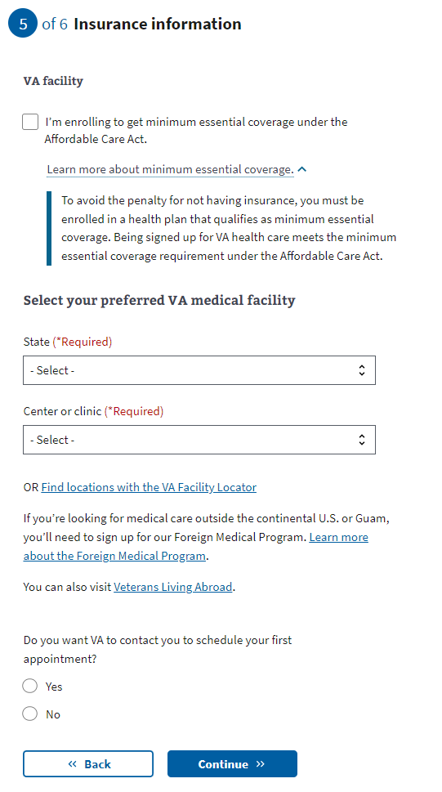

## Review Application

Once the Veteran has completed the application, they will be shown the Review Application section. In this section, the user can open each section and see what information they entered.

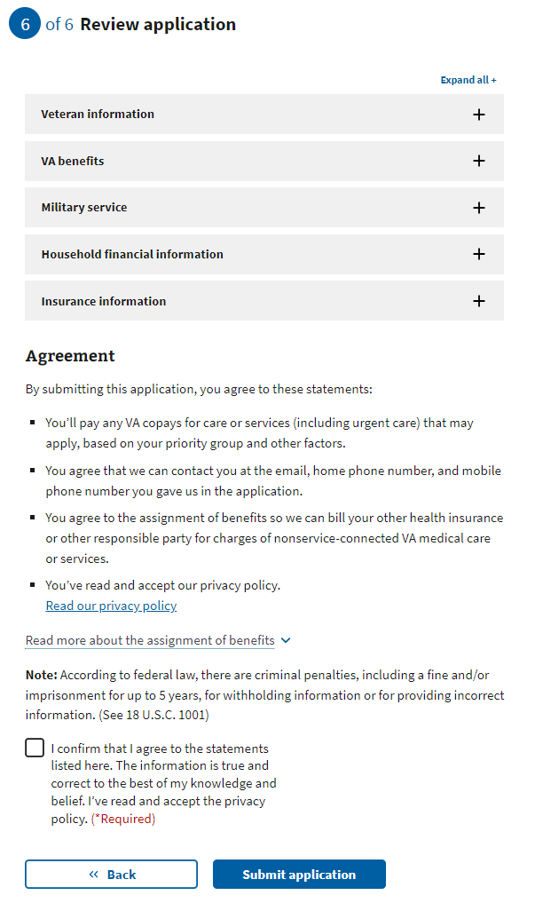

If they want to change the information shown, they can select the “Edit”button and make changes to that information.

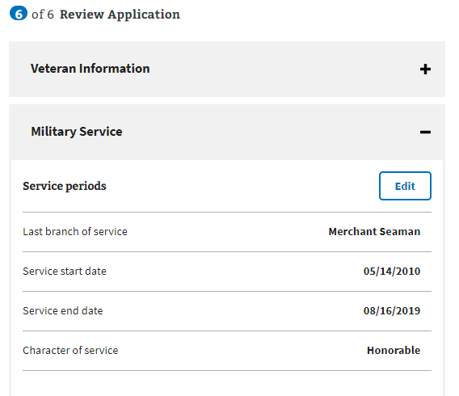

Once the “Edit”button has been pressed, the user can update the information in that section. They’ll need to make sure to press the “Update Page” button to save the changed information.

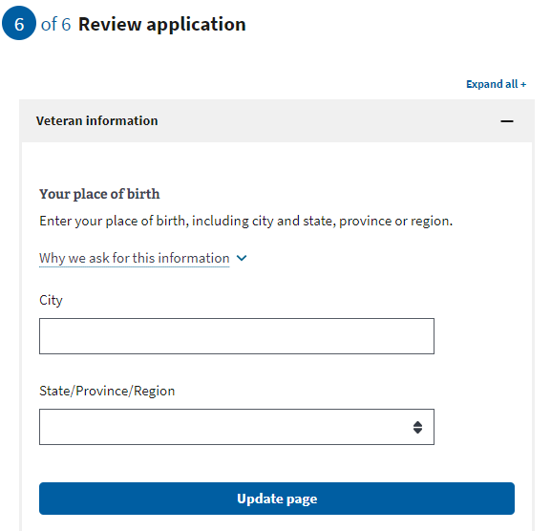

If any of the changes made remove any required information or trigger additional questions that need to be answered, the application will draw their attention to where the update needs to be made.

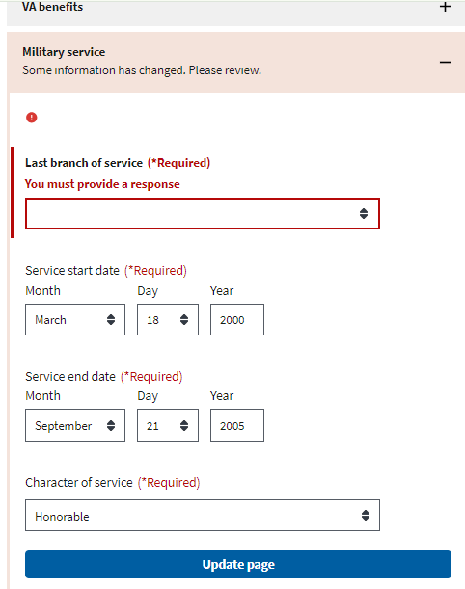

Once the user has reviewed the information and is ready to submit the application, they must select the check box indicating they agree to the statements listed, that the information is true and correct and that they have read and accepted the privacy policy. The privacy policy can be accessed via the link. This will be opened in a new tab and their application won’t be interrupted:

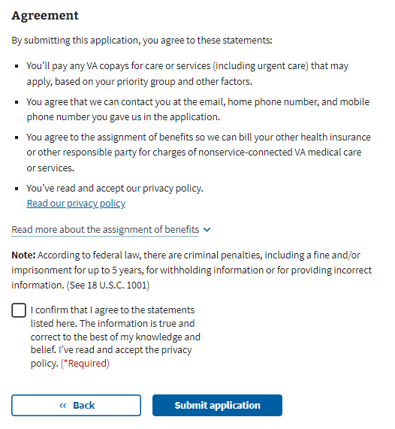

The user will be shown the following information after they submit their application:

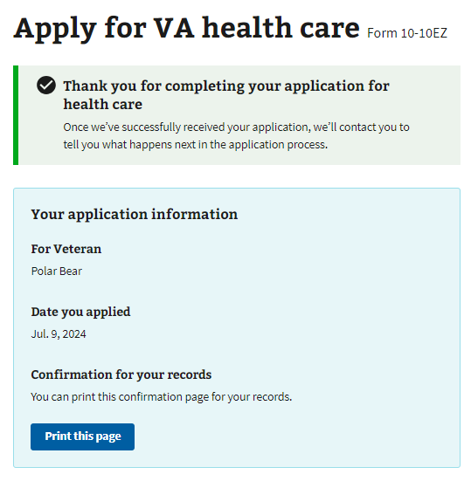

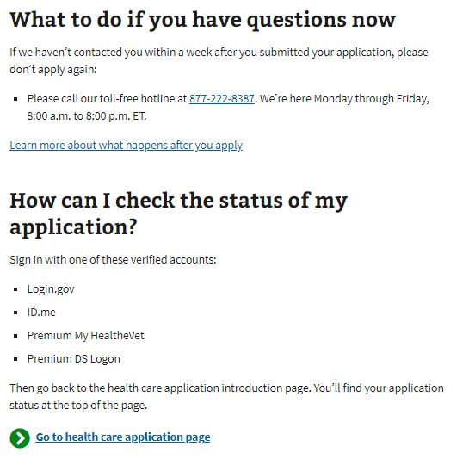

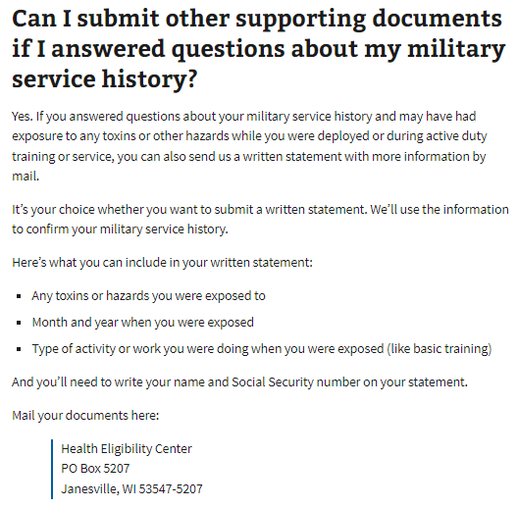

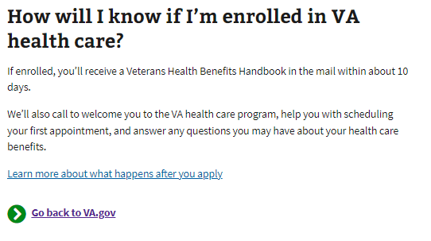

# Health Care Application Issues

## Questions about the content of the application

Many Veterans will have specific questions about the content of the application because they don’t understand what the application is asking or why it needs that information. These are non-technical issues and should be directed to the Health Enrollment Center (HEC). Before transferring the Veteran to this call center, make sure they don’t have any questions related to the navigation or issues entering information for technical reasons.

The information for the HEC is at the bottom of every page in the Health Care Application:

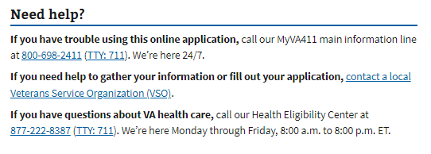

## Application is prefilled with incorrect information

If a Veteran has already entered information about themselves or their account has personal, contact, or military information associated with it, that information will be used to prefill the application. The purpose is to make it easier for the Veteran to complete the application. Sometimes this information is incorrect, and it may confuse the Veteran. They can fix this by editing the information directly in the application.

## Veteran Can’t Move Forward In Their Application

If a Veteran is saying they can’t move on to the next page in the application, ask them to check and make sure they have filled out all the required information. The website will have a big red message indicating where it is missing required information:

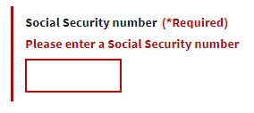

Veteran Can’t Upload a Document

There are a few places where a Veteran might be asked to upload a document to their application. If a Veteran is having difficulty uploading a document, review the tips section below to make sure the Veteran is following the guidelines:

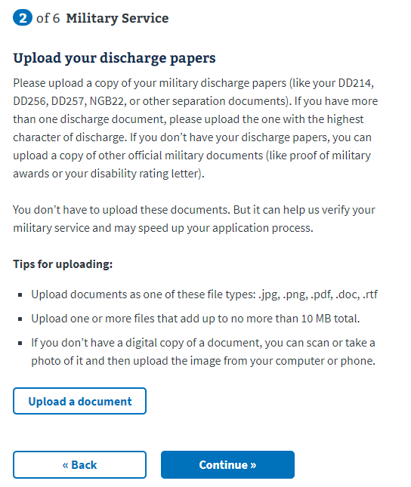

## Veteran is Having Trouble Upgrading Account From LOA1 to LOA3

If a Veteran is trying to apply for health care benefits with their LOA1 (not identity verified account), they will be required to upgrade to an LOA3 (identity verified) account. They can do this using ID.me, Login.gov, or by upgrading their My HealtheVet or DS Logon account. If the Veteran does not want to do this, you can also tell them they can apply for health care benefits when signed out of their account. This is not ideal because they will have to provide more information as they fill out the application, but it is an option if they don’t want to upgrade their account to LOA3.